***R. E. Society’s***

**R. P. Gogate College of Arts & Science and**

**R. V. Jogalekar College of Commerce (Autonomous), Ratnagiri**



**Department of Botany**

**UG Programme 2024-25**

**Syllabus for S. Y. B. Sc. SEC(Botany)**

**Semester III and IV**

**Under Choice Based Credit System (CBCS)**

R. P. Gogate College of Arts & Science and

R. V. Jogalekar College of Commerce (Autonomous), Ratnagiri

**Board of Studies in Botany**

**Academic Year 2024-25**

| **Nomenclature of the Course** | | | **SEC**-**Propagation of Horticultural Plants -II** | | | |
| --- | --- | --- | --- | --- | --- | --- |
| **Class** | | | S.Y.B.Sc. | | | |
| **Semester** | | | 03 | | | |
| **Course Code** | | | USBOTSEC2 | | | |
| **No. of Credits** | | | 02 | | | |
| **Nature** | | | Practical | | | |
| **Type** | | | SEC | | | |
|  | | | | | | |
| **Course Outcomes:** | | | | | | |
| **Students will be able to:**  **CO1:** Gain the knowledge about various propagation techniques for horticultural plants.  **CO2:** Able to propagate the vegetable,spices and medicinal plants by different propagation  techniques.  **CO3:** Learn and perform the stem, root and leaf cutting techniques for propagation of plants.  **CO4:** Learn and perform various techniques for propagation of plants like layering, grafting, budding.  **CO5:** Learn and perform different methods of developing new plant varieties.  **CO6:** To maintain nursery plants. | | | | | | |
|  | | | | | | |
| **Syllabus:** | | | | | | |
| **Unit No.** | | **Unit Title** | | **Sub titles (Learning Points)** | | |
| **1.** | | **Plant Propagation**  **Techniques in Horticultural plants - II** | | **Layering :** Simple , Compound, Air layering  **Grafting :** Definition, advantages and disadvantages.  Types: Splice,Whip/Tongue  **Budding :** Definition, advantages and disadvantages.  Types: Tbudding, Shield  Maintenance of nursery plants  Developing new varieties - Emasculation, Bagging  **Cutting :** Root cutting, Stem cuttings, and leaf cuttings | | |
| **Practical** | | | | | | |
| **1.** | | **Plant Propagation**  **Techniques in Horticultural plants - II** | | To observe different types of pots and potting medium  (Clay, Cement, Porcelain, Plastic, Special type of pots) | | |
| To study Potting and repotting of plants. | | |
| Plant propagation by Stem cutting : *Hibiscus*, Rose | | |
| Plant propagation by Root cutting : - *Aegle marmelos* | | |
| Plant propagation by Leaf cutting : - *Aloe vera* , *Bryophyllum* | | |
| Plant propagation by Simple layering: *Piper longum*, *Piper nigrum* | | |
| Plant propagation by Compound layering: *Pothos* , *Piper nigrum* | | |
| Plant propagation by Air layering: *Cinnamomum zeylanicum* | | |
|  | |  | | Propagation practices by budding- T budding, Shield. | | |
| Propagation practices by grafting - Spliced, Whip grafting. | | |
| Developing new plant varieties by - emasculation technique  -bagging technique | | |
| Maintenance of nursery plants. | | |
| **Prescribed Text/s (If any):**   * Basic Horticulture - Jitendra singh , Kalyani publication,2008. * Propagation practices - M K Sadhu,New age international,1989. * Indoor gardening - S C Dey,Agrobios (india),2003. * Plant propagation and nursery management -Dr. Arun kumar singh,Arun kumar,S K Kataria and Sons Publication,2023. * Instant Horticulture- S N Gupta,Jain Brothers,2023. * Basics of horticulture - K.V.Peter,New India Publishing Agency (NIPA),2021   **Other Learning Resources recommended:** | | | | | | |

**Evaluation Pattern**

1. **Continuous Internal Evaluation: Maximum Marks: 20 marks**

| **Method** | **Marks** |
| --- | --- |
| **Active class participation** | **05 marks** |
| **Journal** | **05 marks** |
| **Class test** | **10 marks** |

1. **Semester End Examination: Maximum Marks: 30 marks**

| **Question No. and Sub questions (If any)** | **Unit and sub unit (with number and title)** | **Type of Question**  **(Essay / short note / Objective / Diagram, etc.)** | **Marks** |
| --- | --- | --- | --- |
| **Q. 1** | **Plant Propagation**  **Techniques** | **Propagation technique** | **10 marks** |
| **Q. 2.** | **Plant Propagation**  **Techniques** | **Potting/Repotting** | **10 marks** |
| **Q. 3.** | **Plant Propagation**  **Techniques** | **Identify and describe** | **10 marks** |

**S.Y.B.Sc.**

**(Skill Enhancement course)**

**Duration- 2 hrs Maximum marks 30**

**Note- Show all the preparations to the examiner.**

| Q.1 | Demonstrate the propagation techniques ---------- and ------------- using specimen A and B. | 10 |
| --- | --- | --- |
| Q.2 | Demonstrate the technique of potting/repotting for the given plant specimen C and D. | 10 |
| Q.3 | Identify the plant part and describe the propagation technique to be followed for specimen E, F, G, H and I. | 10 |

***************************

**Keys:-**

**A and B -** Cutting- stem, leaf cutting

Layering- air layering

Grafting - Spliced/Whip

Budding- T budding

**C and D-** Any two plants from the prescribed syllabus.

**E, F, G, H and I**

The plants other than those kept in Q.1 and 2.

| **Nomenclature of the Course** | | | **SEC**-**Propagation of Horticultural Plants -III** | | | |
| --- | --- | --- | --- | --- | --- | --- |
| **Class** | | | S.Y.B.Sc. | | | |
| **Semester** | | | 04 | | | |
| **Course Code** | | | USBOTSEC3 | | | |
| **No. of Credits** | | | 02 | | | |
| **Nature** | | | Practical | | | |
| **Type** | | | SEC | | | |
|  | | | | | | |
| **Course Outcomes:** | | | | | | |
| **Students will be able to:**  **CO1:** Gain the knowledge about various propagation techniques for horticultural plants.  **CO2:** Able to propagate the vegetable,spices and medicinal plants by different propagation  techniques.  **CO3:** Learn and perform the stem, root and leaf cutting techniques for propagation of plants.  **CO4:** Learn and perform different layering and grafting techniques for propagation of plants.  **CO5:** Learn and perform advanced techniques for nursery management like hydroponics, space garden, vertical farming and soil-less farming. | | | | | | |
|  | | | | | | |
| **Syllabus:** | | | | | | |
| **Unit No.** | | **Unit Title** | | **Sub titles (Learning Points)** | | |
| **1.** | | **Plant Propagation**  **Techniques in Horticultural plants - III** | | **Preparation of beds**  **Propagation by seeds -** Vegetables, Fruits, etc.  **Layering :** Tip, Trench, Mound layering  **Grafting :** Side, veneer, bark, epicotyls, approach, repair grafting – enarching, bridge and bracing  **Advanced Techniques in Horticulture - -**   * Hydroponics * Space garden * Vertical farming * Soil-less farming | | |
| **Practical** | | | | | | |
| **1.** | | **Plant Propagation**  **Techniques in Horticultural plants - III** | | Preparation of beds | | |
| Propagation practices by grafting - Side, veneer | | |
| Propagation practices by grafting - bark, epicotyls | | |
| Propagation practices by grafting - approach, repair grafting – enarching | | |
| Propagation practices by grafting - repair grafting – bridge and bracing | | |
| Plant propagation by Tip layering. | | |
| Plant propagation by Trench layering. | | |
| Plant propagation by Mound layering. | | |
| Propagation by seeds - Vegetables, Fruits, etc. | | |
| Advanced technique in Horticulture - hydroponics. | | |
| Advanced technique in Horticulture - soil-less cultures. | | |
|  | | Advanced technique in Horticulture - space garden. | | |
| Advanced technique in Horticulture - vertical garden. | | |
| **Prescribed Text/s (If any):**   * Basic Horticulture - Jitendra singh , Kalyani publication,2008. * Propagation practices - M K Sadhu,New age international,1989. * Indoor gardening - S C Dey,Agrobios (india),2003. * Plant propagation and nursery management -Dr. Arun kumar singh,Arun kumar,S K Kataria and Sons Publication,2023. * Instant Horticulture- S N Gupta,Jain Brothers,2023. * Basics of horticulture - K.V.Peter,New India Publishing Agency (NIPA),2021   **Other Learning Resources recommended:** | | | | | | |

**Evaluation Pattern**

1. **Continuous Internal Evaluation: Maximum Marks: 20 marks**

| **Method** | **Marks** |
| --- | --- |
| **Active class participation** | **05 marks** |
| **Journal** | **05 marks** |
| **Class test** | **10 marks** |

1. **Semester End Examination: Maximum Marks: 30 marks**

| **Question No. and Sub questions (If any)**  **(E.g. Q. 1 a) …** | **Unit and sub unit (with number and title)** | **Type of Question**  **(Essay / short note / Objective / Diagram, etc.)** | **Marks** |
| --- | --- | --- | --- |
| **Q. 1** | **Plant Propagation**  **Techniques in Horticultural plants - III** | **Propagation technique** | **10 marks** |
| **Q. 2.** | **Preparation of bed/pot** | **10 marks** |
| **Q. 3.** | **Identify and describe** | **10 marks** |

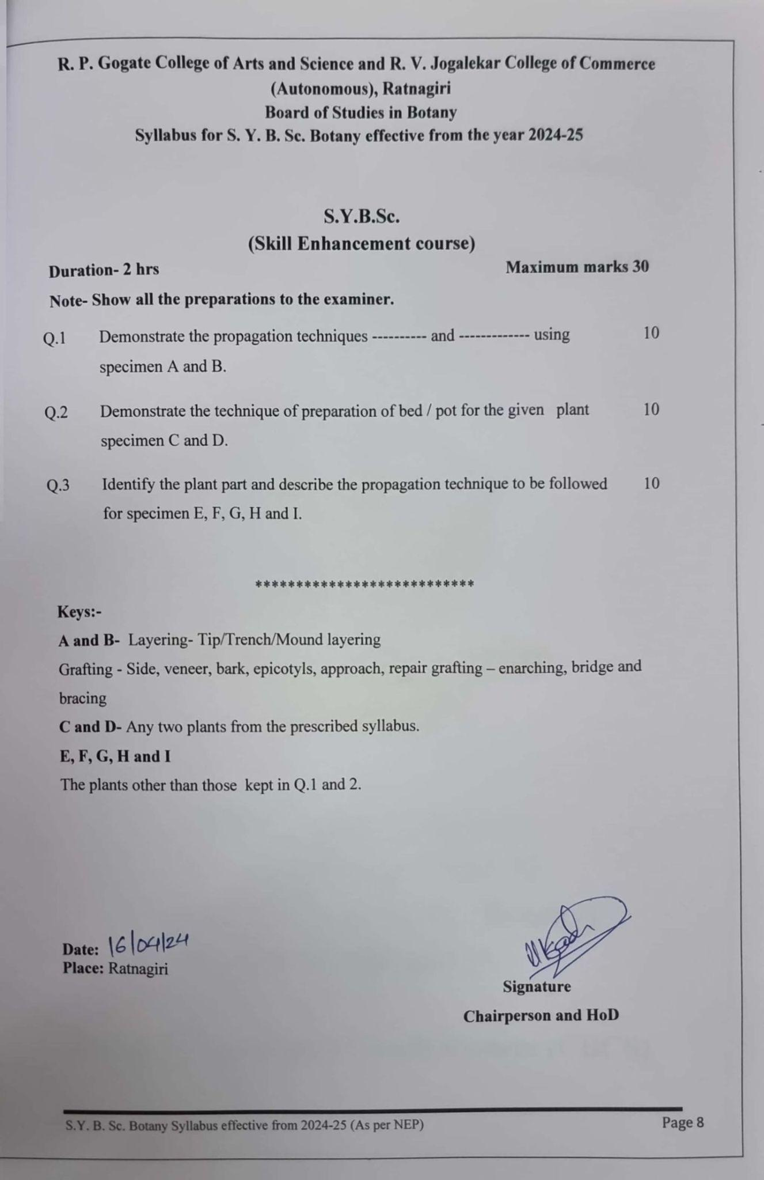

**S.Y.B.Sc.**

**(Skill Enhancement course)**

**Duration- 2 hrs Maximum marks 30**

**Note- Show all the preparations to the examiner.**

| Q.1 | Demonstrate the propagation techniques ---------- and ------------- using specimen A and B. | 10 |
| --- | --- | --- |
| Q.2 | Demonstrate the technique of preparation of bed / pot for the given plant specimen C and D. | 10 |
| Q.3 | Identify the plant part and describe the propagation technique to be followed for specimen E, F, G, H and I. | 10 |

***************************

**Keys:-**

**A and B-** Layering- Tip/Trench/Mound layering

Grafting - Side, veneer, bark, epicotyls, approach, repair grafting – enarching, bridge and bracing

**C and D-** Any two plants from the prescribed syllabus.

**E, F, G, H and I**

The plants other than those kept in Q.1 and 2.

**Date:**

**Place:** Ratnagiri

**Signature**

**Chairperson and HoD**